

REACT JS PROJECT REPORT ON
TITLE OF THE PROJECT

Submitted by
MAHILNILA PARAMESWARAN
24BIT028

Under the Guidance of
Aravind
Technical Trainer
Technical Department, KG College of Arts and Science

Academic Year: 2025 – 2026
APRIL 2026

DECLARATION
I hereby declare that the project entitled “ONLINE CODING PRACTICE UI” submitted in partial fulfillment of the requirements for the course REACT JS is a record of my original work carried out under the guidance of ARAVIN, Technical Trainer, Technical Department, KG College of Arts and Science.
I further declare that this project has not been submitted previously, either in part or in full, for the award of any degree, diploma, or other similar title, at this or any other institution.
I have acknowledged all sources of information used in this project wherever applicable.

April 2026
Coimbatore

MAHILNILA P (Your Name)

CERTIFICATE
This is to certify that the project entitled “ONLINE CODING PRACTICE UI” is a bona fide work carried out by MAHILNILA P [II-B.Sc.IT(“A”)], [B.Sc.INFORMATION TECHNOLOGY], KG College of Arts & Science, in partial fulfillment of the requirements for the course REACT JS.
This project has been completed under my supervision and guidance during the academic period April 2026.

Place:
Date: 09-04-26

Submitted for the Viva-Voce Examination held on :_09-04-26_

Guide: Head of the Department
(Technical Trainer, KGCAS) (Technical Head, KGCAS)

______________________ _______________________

TABLE OF CONTENTS
S. No. | Topics | Page. No.
1 | Introduction
1.1 | Background of the Study
1.2 | Problem Statement
1.3 | Objectives of the Project
1.4 | Purpose and Significance
1.5 | Scope and Limitations
1.6 | Methodology Overview
2 | System Analysis
2.1 | Existing System
2.2 | Drawbacks of the Existing System
2.3 | Proposed System
2.4 | Features of the Proposed System
2.5 | Feasibility Study
2.6 | Requirement Analysis
3 | System Design
3.1 | System Architecture
3.2 | Use Case Diagram
3.3 | Data Flow Diagram (DFD)
3.4 | Entity Relationship Diagram (ERD)
3.5 | User Interface Design
4 | System Implementation
4.1 | Development Tools
4.2 | Module Description
4.3 | Algorithms
4.4 | System Integration
4.5 | Security and Validation
5 | System Testing
5.1 | Testing Methodology
5.2 | Test Cases
5.3 | Error Handling
5.4 | Performance
6 | Input and Output Screens
6.1 | System Outputs
6.2 | Discussion
6.3 | Comparison
6.4 | User Feedback
7 | Conclusion and Future Enhancement
7.1 | Summary
7.2 | Limitations
7.3 | Future Scope
8 | References
Appendices
- Source Code Snippets
- Screenshots of Web Pages

ABSTRACT
The Online Coding Practice UI project is a web-based application developed to provide an interactive platform for practicing programming skills. It allows users to select coding problems, write code, and view outputs in real-time through a user-friendly and responsive interface. The system is developed using ReactJS, along with modern web technologies such as JavaScript and CSS, ensuring smooth performance and cross-platform compatibility.
The project aims to simplify coding practice by offering multiple problem statements, an integrated code editor, and instant output display. JavaScript is used for dynamic rendering of components, handling user interactions, and executing code using browser-based evaluation techniques. The modular architecture, consisting of components, pages, and a separate data layer, ensures maintainability and scalability.
This project demonstrates how frontend technologies can be effectively used to simulate an online coding platform. It provides a strong foundation for future enhancements such as backend compiler integration, multi-language support, user authentication, test case evaluation, and performance tracking.
Overall, the system enhances learning by creating an engaging and interactive environment for coding practice.

Chapter 1: Introduction
1.1 Background of the Study
In the modern era, technology has significantly transformed the way programming skills are learned and practiced. Traditional learning methods are increasingly being supplemented by online platforms that provide interactive coding environments. Online coding platforms enable users to practice problems, write code, and receive instant feedback, thereby improving problem-solving skills and logical thinking.
This project focuses on developing an Online Coding Practice User Interface (UI) using ReactJS. The application provides a platform where users can access coding problems, write solutions in a code editor, and view outputs instantly. By leveraging modern web technologies such as JavaScript and CSS, the system ensures a responsive and user-friendly experience.

1.2 Problem Statement
Many learners face difficulties in practicing programming effectively due to the lack of accessible and interactive coding environments. Existing platforms may be complex, require subscriptions, or lack simplicity for beginners. Additionally, not all platforms provide a clean and distraction-free interface for practicing basic coding problems.
Therefore, there is a need for a simple, efficient, and interactive web-based platform that allows users to practice coding problems, write and execute code, and view results in real-time within an easy-to-use interface.

1.3 Objectives of the Project
• To design and develop an interactive online coding practice UI using ReactJS
• To provide multiple coding problems for practice
• To implement a real-time code editor for writing and testing code
• To display output dynamically using JavaScript execution
• To ensure the application is responsive and user-friendly

1.4 Purpose and Significance of the Study
The main purpose of this project is to provide an engaging platform for practicing programming concepts in an interactive manner. It helps users improve coding skills through hands-on experience and instant feedback.
This project contributes to digital learning by demonstrating how frontend technologies can be used to simulate a coding platform. It serves as a foundation for developing more advanced systems with backend integration, multi-language support, and user management features.

1.5 Scope and Limitations
Scope:
The project focuses on developing the frontend of an online coding platform, including problem listing, code editor integration, and output display functionality.
Limitations:
- Only JavaScript code execution is supported using browser-based evaluation
- No backend integration for compiling other programming languages
- No user authentication or database storage
Future enhancements can include backend compiler integration, support for multiple programming languages, and user-specific features.

1.6 Methodology Overview
The project follows a structured Software Development Life Cycle (SDLC) approach, which includes:
- Requirement Analysis
- System Design
- Development
- Testing
- Implementation
The development is carried out using tools such as Visual Studio Code, ReactJS, JavaScript, and CSS. The application is designed using a modular approach with components, pages, and a separate data layer to ensure scalability and maintainability.

Chapter 2: System Analysis
2.1 Existing System
In the existing system, learners typically rely on traditional methods such as textbooks, classroom teaching, or static websites to practice programming. Some online platforms do provide coding environments, but they are often complex, require subscriptions, or are not beginner-friendly.
Many static websites only provide problem statements without offering an interactive coding environment. As a result, users need to switch between multiple tools to write and test code, which reduces efficiency and interrupts the learning process.

2.2 Drawbacks of the Existing System
- Lack of integrated coding environment for practice
- Static content without real-time interaction
- No immediate feedback for user-written code
- Complex interfaces in existing platforms for beginners
- Dependence on external tools for code execution.

2.3 Proposed System
The proposed system is an Online Coding Practice UI that provides a centralized and interactive platform for practicing programming problems. The application is built using ReactJS and modern web technologies to create a responsive and user-friendly interface.
Users can select coding problems, write code in an integrated editor, and execute it instantly within the browser. The system uses JavaScript-based evaluation to display real-time output, eliminating the need for external tools. This approach enhances the learning experience by providing a seamless and interactive coding environment.

2.4 Features of the Proposed System
• Interactive and responsive user interface
• Integrated code editor for writing solutions
• Real-time code execution and output display
• Multiple coding problems for practice
• Navigation between different pages (Dashboard and Practice)
• Modular structure using components, pages, and data layer
• Option to extend for multi-language support and backend integration

2.5 Feasibility Study
Technical Feasibility:
The project is developed using ReactJS, JavaScript, and CSS, which are widely used, open-source technologies. The use of browser-based execution ensures easy deployment and cross-platform compatibility.
Economic Feasibility:
The development cost is minimal as it uses free tools such as Visual Studio Code and open-source libraries. No additional hardware or licensed software is required.
Operational Feasibility:
The system is simple and user-friendly, allowing users to practice coding without any prior training. The interface is intuitive and easy to navigate, making it suitable for beginners.

2.6 Requirement Analysis
Functional Requirements:
- Display a list of coding problems
- Allow users to select a problem
- Provide a code editor for writing solutions
- Execute code and display output instantly
- Navigate between different pages
Non-Functional Requirements:
- Fast performance and quick response time
- User-friendly and intuitive interface
- Responsive design for different screen sizes
- Maintainable and scalable code structure
- Secure execution of user input within browser limitations

Chapter 3: System Design
3.1 Introduction
System design defines the architecture, structure, and data flow of the Online Coding Practice UI Project. It converts requirements into a working blueprint. The design focuses on how users interact with coding problems, the code editor, and the execution system.
3.2 System Architecture
The system follows a three-layer architecture:
1. Presentation Layer (Frontend)
- Built using ReactJS
Handles user interface and user interactions
Displays problems, editor, and output
2. Application Logic Layer
Handles logic such as:
  - Problem selection
  - Code execution using JavaScript eval()
  - State management using React
3. Data Layer
Stores coding problems in a structured format (problems.js)
Contains:
  - Problem title
  - Description
  - Starter code

Description:
• The Presentation Layer manages UI components like ProblemList, CodeEditor, and ResultPanel.
• The Application Layer processes user actions and executes code dynamically.
• The Data Layer provides problem data to the application.
3.3 Use Case Diagram
1. What is a Use Case Diagram?
A Use Case Diagram represents:
- Actors → users interacting with the system
- Use Cases → actions performed by users
- Relationships → interaction between actors and system
It explains “who does what” in the system.

2. Identify the Main Actors :
Actor | Description
User | Selects problems, writes code, and runs programs

3. Identify the Main Use Cases
• View Problem List
• Select Problem
• Write Code
• Run Code
• View Outpu
4. Define Relationships
Symbol | Meaning
Solid line | Association (Actor performs a use case)
<<include>> | A mandatory sub-task inside another use case
<<extend>> | An optional or conditional task
Example:
“Run Code” <<include>> “Execute Code”
→ When a user clicks Run Code, the system must execute the code internally
“Run Code” <<include>> “Display Output”
→ After execution, output must always be shown
“View Output” <<extend>> “Run Code”
→ Output is shown only after the user runs the code
“Select Problem” (Association) User → Problem List
→ User selects a problem from the list
5. Draw the Diagram (Structure Example)
Tools you can use:
- draw.io (free online)
- Lucidchart
- StarUML
- MS Visio
+--------------------------------------+
| Online UI Coding System |
| |
| (View Problems) |
| (Select Problem) |
| (Write Code) |
| (Run Code) --------<<include>>---- (Execute Code)
| | |
| |----<<include>>------------ (Display Output)
| |
| (View Output) ----<<extend>>---- (Run Code)
| |
+--------------------------------------+

↑
User

6. Example Explanation (Text Description)
Actors:
User (Student/Programmer):
The main actor who interacts with the system to solve coding problems, write code, and view outputs.
Administrator (Optional):
Manages coding problems, updates problem data, and maintains the system.
Use Cases:
View Problems:
User browses the list of available coding problems.
Select Problem:
User selects a specific problem to solve.
Write Code:
User writes or edits code in the code editor.
Run Code:
User executes the written code.
View Output:
System displays the output or error message.
Reset Code (Optional):
User resets the code to the default starter code.
Manage Problems (Admin):
Admin can add, edit, or delete coding problems.

Relationships:
“Run Code” <<include>> “Execute Code”
→ Code execution is mandatory when user runs code
“Run Code” <<include>> “Display Output”
→ Output must always be shown after execution
“View Output” <<extend>> “Run Code”
→ Output is visible only after running the code
“Manage Problems” <<include>> “Add / Edit / Delete Problem”
→ Admin actions are part of problem management
7. Step-by-Step (Using draw.io)
• Go to https://app.diagrams.net
• Choose Blank Diagram → Name it “Use Case Diagram – Online Coding System”
• From the left panel, drag:
- Stick figure → User / Admin (Actors)
- Oval shapes → Use Cases (View Problems, Run Code, etc.)
- Rectangle → System Boundary (Online UI Coding System)
• Connect:
- Actors ↔ Use Cases using solid lines
- Use Cases using:
  - <<include>> (dashed arrow)
  - <<extend>> (dashed arrow)
• Clearly label all relationships
• Export as PNG/JPG and insert into your repor

3.4 Data Flow Diagram (DFD)
1. What is a Data Flow Diagram (DFD)?
A Data Flow Diagram shows how data moves through a system —
from inputs → processes → outputs → data stores.
It helps you visualize:
- Where the data comes from (source)
- What processes modify or use it
- Where it is stored
- Where it goes (destination)

2. DFD Symbols You’ll Use
Symbol | Meaning
Rectangle | External Entity (e.g., Student, Admin)
Circle / Rounded Rectangle | Process (e.g., “Validate Login”, “Display Courses”)
Two Parallel Lines | Data Store (e.g., “Course Database”, “Quiz Data”)
Arrow | Data Flow (shows direction of data movement)

3. Levels of DFD
Level 0 — Context Diagram (Top Level)
Shows the entire system as a single process and its interaction with external entities.
Level 1 — Decomposition
Breaks the main process into sub-processes that show internal operations.
Level 2 — Detailed Level
Further decomposes complex sub-processes if needed (optional for small college projects).

4. Steps to Create a DFD
Step 1: Identify External Entities
- User (Student/Programmer)
- Administrator (Optional)

Step 2: Identify Main Processes
- Display Problem List
- Load Selected Problem
- Execute Code
- Display Output
- Manage Problems (Admin)

Step 3: Identify Data Stores
- Problem Data Store (problem.js / JSON)
- User Code (temporary input)
- Output Data (execution result)

Step 4: Identify Data Flows
- “Request Problem List”
- “Problem Details”
- “User Code Input”
- “Execution Result / Output”

5. DFD for Educational Website
Level 0: Context Diagram
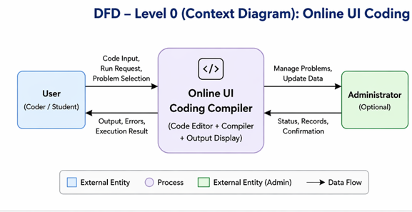
Explanation:
- The user write code,select problems, and run the code.
- The system processes the code and returns output or error messages.
- The Adminstrator adds, updates, or deletes problems.
- This diagram shows the system as a single process and its interaction with external entities.

Level 1: Detailed System View
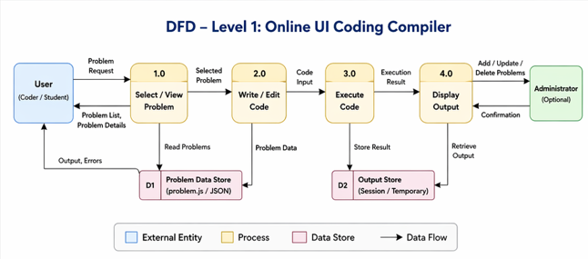
Explanation:
- Select/View Problem (1.0):
The user requests and views available coding problems. The system retrieves problem data from the Problem Data Store (JSON or local data) and displays it to the user.
- Write/Edit Code (2.0):
The user writes or modifies code in the code editor. The selected problem and starter code are used as a reference for writing the solution.
- Execute Code (3.0):
The system compiles and runs the user’s code. This process handles the execution logic and generates results or error messages.
- Display Output (4.0):
The system displays the execution result, including output or errors, to the user. The result may be temporarily stored in the Output Data Store.

Level 2: Quiz Process (Example Sub-process)
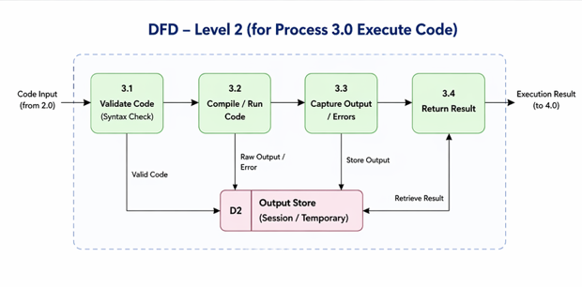

6. Tools to Draw Your DFD
Free, easy online tools:
- https://app.diagrams.net (recommended)
- Lucidchart
- Creately
- StarUML
- Microsoft Visio
Steps (in draw.io):
- Go to https://app.diagrams.net.
- Choose Blank Diagram → name it “DFD_EducationalWebsite”.
- Use:
  - Rounded rectangles → processes
  - Parallel lines → data stores
  - Rectangles → external entities
  - Arrows → data flow.
- Label everything clearly (arrows = data names).
- Export as .PNG or .JPG and insert into your report.

3.5 Entity Relationship Diagram (ERD)
Entities and Relationships:
• User (User_ID, Name, Email)
• Problem (Problem_ID, Title, Description, Starter_Code)
• CodeSubmission (Submission_ID, User_ID, Problem_ID, Code, Output, Status)
• Result (Result_ID, Submission_ID, Output, Errors)
Relationships:
- A User can solve multiple Problems
- A Problem can have multiple Code Submissions
- Each Code Submission generates one Result
- A User can have multiple Results through submissions
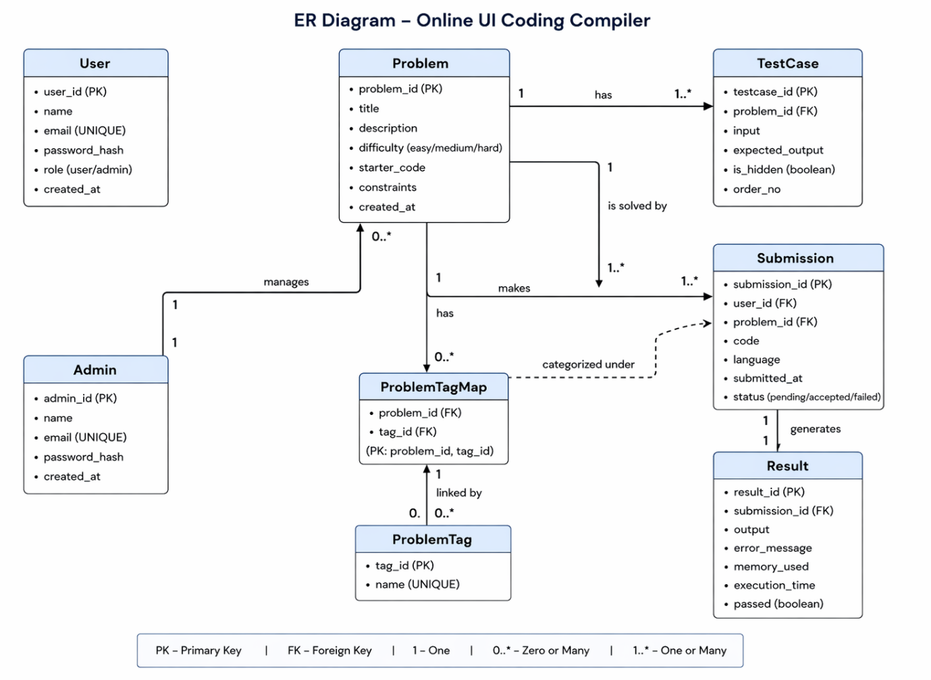
3.6 User Interface Design
The User Interface (UI) of the Online UI Coding Compiler is designed to be simple, responsive, and user-friendly. It ensures smooth interaction between the user and the system. The interface is developed using HTML for structure, CSS/Bootstrap for styling, and JavaScript for dynamic behavior and interactivity. The design focuses on clarity, ease of navigation, and real-time feedback for users while writing and executing code.
Main Pages:
- Homepage: Shows a list of coding problems. Users can select any problem.
- Code Editor Page:
Users can:
Read the problem
Write or edit code
Click Run Code button
- Output Page: Displays Output of the program, errors (if any)
- Navigation Bar (Optional) : Helps users move between pages easily.

Chapter 4: System Implementation
4.1 Introduction
System implementation is the phase where the system design is converted into a working application. In this project, the Online Coding Practice UI is implemented using ReactJS and modern web technologies.
This phase includes developing user interface components, integrating modules, handling user interactions, and enabling real-time code execution. The system is designed to provide a smooth and interactive coding experience within the browser.

4.2 Development Tools and Technologies
Tool / Technology | Purpose
ReactJS | Builds dynamic and component-based UI
Javascript(ES6) | Handles logic, state, and code execution
Monaco Editor | Provides code editor interface
CSS | Styling and responsive design
Vite | Fast development server and buid tool
Visual Studio Code | Development environment
Browser | Running and debugging application

4.3 System Modules Description
Module | Description
Navbar Module | Provides navigation between pages
ProblemList Module | Displays list of coding problems
CodeEditor Module | Allows users to write and edit code
ResultPanel Module | Displays output of executed code
Practice Page | Integrates all components for coding
Dashboard Page | Entry oage for the application
Each module is designed as a reusable React component and integrated using props and state management.
4.4 Implementation Details
The implementation follows a modular and component-based approach:
- Frontend Design:
The user interface is developed using HTML for content and CSS for styling.
- Dynamic Behavior:
The user interface is built using ReactJS components and styled using CSS for a clean and responsive layout.
- Event Handling:
User actions such as selecting a problem and clicking the “Run Code” button are handled using event listeners in React.
- Code Evaluation Logic:
The entered code is executed using JavaScript’s eval() function, which dynamically runs the code in the browser and returns output.
- Data Management:
All coding problems are stored in a separate file (problems.js) and passed to components as props, ensuring separation of concerns and maintainability.

4.5 Algorithm / Logic of Core Function
Algorithm for Code Evaluation:
• Get code input from the editor
• Pass the code to the execution function
• Use eval() to execute the code
• Capture the output or error
• Display result in the output panel

Algorithm for Problem Selection:
- Load problem list from data file
- Display problems in ProblemList component
- On user click, select the problem
- Load corresponding starter code into editor

4.6 Security and Validation
- Basic validation ensures that empty code is not executed
- Error handling is implemented using try-catch blocks
- Since execution uses eval(), only JavaScript is supported
- No sensitive data is stored or transmitted

4.7 Integration
All components are integrated using React’s component hierarchy:
- The Practice Page acts as the main container
- It passes data to:
  - ProblemList
  - CodeEditor
  - ResultPanel
State is managed centrally and passed using props, ensuring smooth communication between components without page reloads.

4.8 Output Screens (Snapshots)
Include screenshots of the following:
- Dashboard Page – Application entry interface
- Problem List – Display of coding problems
- Code Editor – User writing code
- Output Panel – Display of execution result

Chapter 5: System Testing
5.1 Introduction
System testing is an essential phase that ensures the developed application meets all functional and non-functional requirements. It verifies whether the system behaves correctly under different conditions.
For the Online Coding Practice UI, testing was performed to validate the functionality of key modules such as problem display, code editor, code execution, and output generation. The goal was to ensure a smooth and error-free user experience.

5.2 Objectives of Testing
- To ensure all modules (ProblemList, CodeEditor, ResultPanel) function correctly
- To detect and fix logical and runtime errors
- To verify correct execution of user-written code
- To ensure smooth navigation between pages
- To test responsiveness across different devices and browsers

5.3 Types of Testing Performed
a) Unit Testing
Each component and function was tested individually. For example:
- Code execution logic using eval()
- Problem loading from problems.js
- Output display functionality
b) Integration Testing
All components were integrated and tested together to ensure smooth interaction between:
- ProblemList → CodeEditor → ResultPanel
c) System Testing
The complete application was tested as a whole to ensure all functionalities worked correctly, including:
- Problem selection
- Code execution
- Output display
d) User Acceptance Testing (UAT)
The system was tested by users (students) to evaluate:
- Ease of use
- UI design
- Responsiveness
Feedback was collected and minor improvements were made.
e) Cross-Browser and Device Testing
The application was tested on:
- Google Chrome
- Microsoft Edge
It was also tested on:
- Laptop
- Mobile devices
to ensure responsive design.

5.4 Test Plan
Test ID | Module | Test Description | Type | Expected Output | Status
T01 | Problem List | Display all problems | Functional | Problems listed correctly | Pass
T02 | CodeEditor | Load starter code | Functional | Code appears in editor | Pass
T03 | Code Execution | Run user code | Logic | Correct output displayed | Pass
T04 | Result Panel | Display output | Output | Output shown correctly | Pass
T05 | Navigation | Switch between pages | Integration | Smooth navigation | Pass
T06 | Input Validation | Run empty code | Validation | Error or message shown | Pass
T07 | Responsiveness | Mobile view | UI | Layout adjusts properly | Pass

5.5 Test Data and Execution
Sample coding problems were stored in problems.js. These problems were loaded dynamically into the application.
User-written code was executed using JavaScript, and outputs were verified by comparing expected results with actual results displayed in the output panel.

5.6 Error Handling
• Empty or invalid code inputs are handled using validation checks
• Runtime errors are captured using try-catch blocks
• Error messages are displayed to guide the user
• Invalid operations during code execution are safely handled
5.7 Performance and Usability Testing
• Performance: Application loads quickly and executes code instantly
• Usability: Interface is simple, clean, and easy to use
• Responsiveness: Works well on different screen sizes
• Accessibility: Clear layout and readable fonts improve user experience
5.8 Results and Observations
All modules functioned correctly without major issues. The application performed efficiently across different devices and browsers.
User feedback indicated that the system is interactive, easy to use, and helpful for practicing coding problems. No critical errors were found in the final testing phase.

Chapter 6: Results and Discussion
6.1 Introduction
This chapter presents the results obtained after implementing and testing the Online Coding Practice UI. It evaluates how effectively the system performs its intended functions, including problem display, code execution, and output generation.
6.2 System Outputs : During execution, the system produced the following outputs:
- Problem List Page: Displays coding problems with titles and descriptions.
- Code Editor: Loads starter code dynamically for selected problems.
- Run Code Feature: Executes user-written JavaScript code.
- Output Panel: Displays results or error messages instantly.
All components work dynamically without page reload, ensuring a smooth user experience.

6.3 Performance Analysis
• Responsiveness: Fast UI rendering with minimal delay
• Execution Speed: Code runs instantly using JavaScript execution logic
• Accuracy: Outputs match expected results when correct logic is used
• Stability: No major runtime crashes during testing
• Cross-Browser Compatibility: Works consistently on Chrome and Edge
6.4 User Feedback
Feedback from users (students) indicated:
- Easy-to-use interface
- Clean and understandable code editor
- Helpful for practicing basic coding problems
- Suggested improvements:
  - Support for more programming languages
  - Save progress feature
  - Backend-based execution for advanced problems

Chapter 7: Conclusion and Future Enhancement
7.1 Conclusion
The Online Coding Practice UI Project successfully demonstrates how front-end technologies can be used to build an interactive coding platform. Using JavaScript, the system allows users to write, run, and test code in real time.
The project achieved its objectives by:
- Providing a simple coding interface
- Enabling dynamic problem loading
- Executing user code and displaying results instantly
All modules, including problem selection, code editor, and output display, function efficiently. The system is responsive, user-friendly, and suitable for beginners learning programming.
This project serves as a foundation for building a full-scale online coding platform.

7.2 Limitations
• Supports only JavaScript code execution
• No backend or server-side execution
• No user authentication system
• Data stored locally (no database integration)
• Limited number of coding problems
7.3 Future Enhancement
The system can be improved with the following features:
Multi-language
Add support for Python, Java, and C++ using backend compilers
Backend Intergration
Use Node.js or API s to execute code securely
User Authentication
Implement login and registration system
Database Integration
Store user progress, problems, and submissions
Admin Dashboard
Manage coding problems dynamically
Code Editor Upgrade
Intergrate advanced editors like Monaco Editor
Online Judge System
Add test cases and automatic evalution
Cloud Deployment
Deploy using platforms like Firebase or AWS

Chapter 8: References
8.1 Books & Journals
• Web Technologies: HTML, CSS, JavaScript — Uttam K. Roy
• Learning Web Design — Jennifer Niederst Robbins
• JavaScript: The Good Parts — Douglas Crockford
8.2 Online Resources
• MDN Web Docs — https://developer.mozilla.org
• W3Schools — https://www.w3schools.com
• JavaScript.info — https://javascript.info
• FreeCodeCamp — https://www.freecodecamp.org
• GeeksforGeeks — https://www.geeksforgeeks.org
8.3 Tools & Frameworks Used
• Editor: Visual Studio Code
• Languages: HTML5, CSS3, JavaScript (ES6)
• Framework (Optional): React.js
• Storage: LocalStorage / JSON
• Browser: Google Chrome / Microsoft Edge

Appendices
Appendix A – Source Code
Main files of the project:
- index.js / App.js — Main application structure
- problem.js — Contains coding problems data
- CodeEditor.jsx — Code editor component
- ProblemList.jsx — Displays problem list
- OutputPanel.jsx — Displays execution output
(Include only important code snippets in the report.)

Appendix B – Screenshots
Include screenshots such as:
- Homepage / Problem List
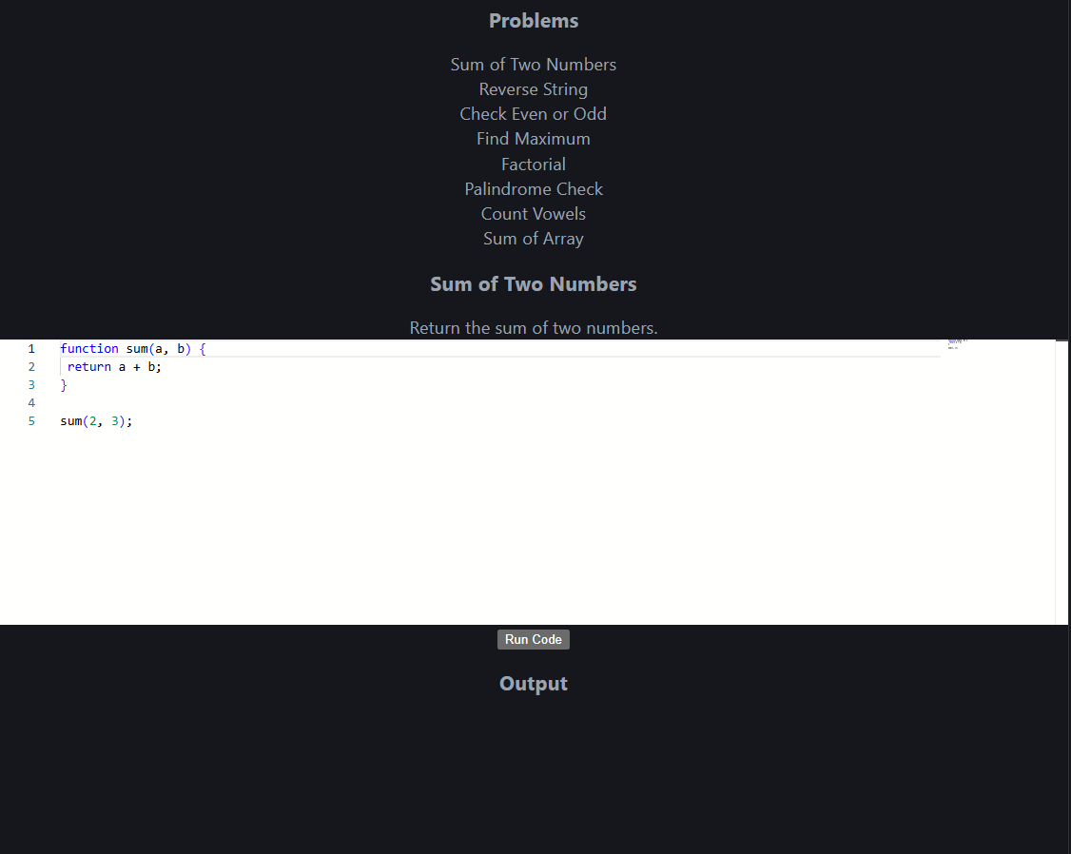

- Code Editor Interface
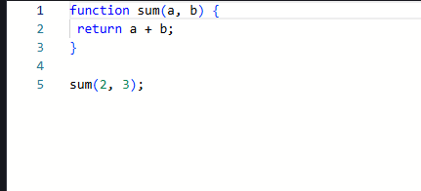
- Code Execution Output
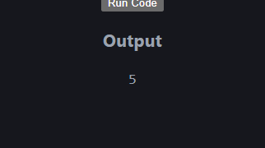
- Error Handling Display
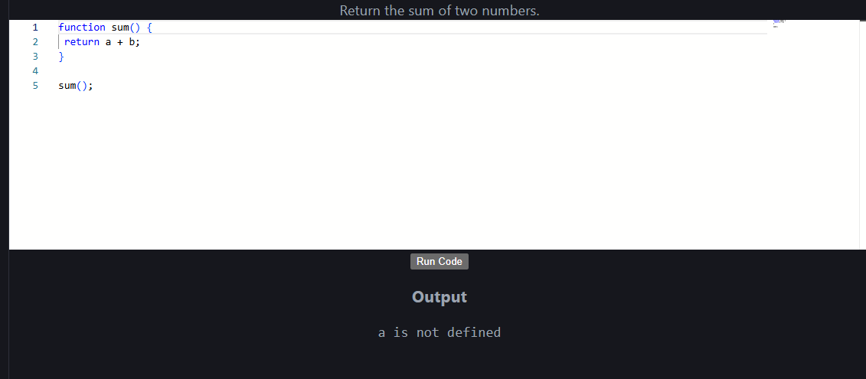

Appendix C – User Manual / Installation Guide
Steps to Run the Project
- Download the project files
- Open the project folder in Visual Studio Code
- Run the application using:
  - npm install
  - npm start
- Open in browser (localhost)
- Select a problem, write code, and click Run
- View output instantly
.
System Requirements:
• OS: Windows / macOS / Linux
• Browser: Chrome / Edge
• RAM: Minimum 4 GB
• Storage: 200 MB free

